**Filtering Noisy Audio**

**Project Proposal**



**Spring 2023**

**CSE301L Signals & Systems Lab**

Submitted by:

**Shahzad Bangash(21PWCSE1980),**

**Suleman Shah(21PWCSE1983),**

**Ali Asghar(21PWCSE2059)**

Class Section: **C**

“On my honor, as student of University of Engineering and Technology, I have neither given nor received unauthorized assistance on this academic work.”

Submitted to:

**Engr. Sumayyea Salahuddin**

Date:

**May 28, 2023**

**Department of Computer Systems Engineering**

**University of Engineering and Technology, Peshawar**

## Problem Statement:

Audio data plays a crucial role in various applications, including speech recognition, audio transcription, telecommunication, and multimedia content production. However, due to many sources of noise that might weaken the overall audio signal, recording clear, high-quality audio can be difficult. Background noise, the environment, the constraints of the recording device, or transmission artefacts can all cause noise. Noise in audio recordings makes it difficult to accurately analyze, comprehend, and utilize the data.

## Introduction:

The problem at hand is the need for an efficient and effective noise filtering solution for audio data. The objective is to develop a system that can filter out noise from audio recordings, thereby improving audio quality and enhancing the intelligibility of the desired signal.

## Objectives:

The goal of this project is to create a sophisticated noise filtering method for audio data that efficiently detects and suppresses noise for better audio quality and better comprehension of the target information.

By successfully overcoming these difficulties, the proposed noise filtering solution will offer a useful tool for numerous industries and applications that heavily rely on high-quality audio data, enhancing the creation of multimedia content and improving the accuracy of speech recognition, audio transmission clarity, and audio analysis.

## Working Flow:

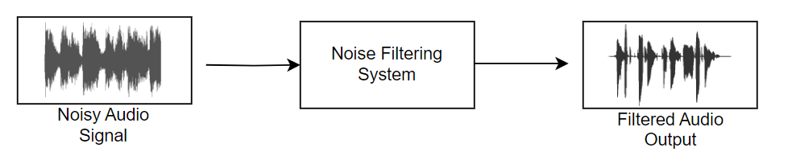

Figure 1-1: Working Flow of Noise Filtering System

Figure 1-1 shows the overall working of this project. The system will apply a filtering technique to a noisy audio signal. It will then start analyzing the frequency content and phase information of the signal and visualize the system's frequency response. It will then calculate the impulse response of the filter and plot it. The system will combine concepts such as Fourier transform, filter design, impulse response, convolution, and audio processing to enhance the quality of the noisy audio signal.

**Working Platform/Software:**

The proposed noise filtering solution for audio data will be implemented using MATLAB, a widely used programming language and environment for scientific and engineering applications. MATLAB offers a comprehensive set of signal processing functions, numerical algorithms, and visualization tools that are well-suited for developing and testing the noise filtering algorithm. By leveraging the capabilities of MATLAB, we can efficiently process audio data, perform various signal processing operations, and evaluate the performance of the filtering algorithm.

Figure 2-1: MATLAB Logo

## Conclusion:

By successfully tackling these challenges, the proposed noise filtering solution will provide a valuable tool for numerous industries and applications that heavily rely on high-quality audio data, contributing to improved speech recognition accuracy, clearer audio transmissions, more accurate audio analysis, and enhanced multimedia content production.